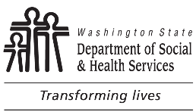 | RESIDENTIAL CARE SERVICES (RCS)  ADULT FAMILY HOME (AFH)  AFH Change in Licensed Bed Capacity - Decrease
There is no fee to decrease the number of licensed beds. There is NO REFUND of any portion of the per bed fee you paid. You must have a minimum of two (2) licensed beds to be an Adult Family Home.
Email the completed form to Business Operations and Analysis Unit (BOA) at RCSBOA@dshs.wa.gov or mailing it to BOA, PO Box 45600, Olympia WA 98504-5600.
AFH NAME |  | AFH LICENSE NUMBER | COUNTY
Licensed bed change: Capacity DECREASE of beds
TOTAL number of beds to be licensed:
Name and phone number of the primary contact for questions:
PRINT NAME |  | PHONE NUMBER (WITH AREA CODE) | DATE
PRINT TITLE

For ALTSA / RCS Use Only
Please type or print clearly. Answer all questions and follow all instructions. Please refer to WAC 388-76-10030. It is the responsibility of the licensee to submit a complete form and fee. Contact 360-725-3700 if you have questions about this form. This form may be photocopied.

