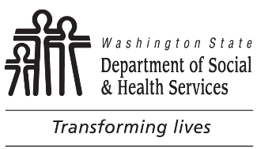 | STATE OF WASHINGTON  DEPARTMENT OF SOCIAL AND HEALTH SERVICES  DIVISION OF CHILD SUPPORT (DCS)  Request for Conference Board  (WAC 388-14A-6400)
Instructions
To request a Conference Board, complete this form and return it to the Division of Child Support (DCS) at the address or Fax number listed below. Instead of using this form, you may contact DCS and make an oral request for a Conference Board. Except for your signature, print all responses. Use blue or black ink. Attach additional pages if needed.
Except for your signature, print all responses. Use blue or black ink. Attach additional pages if needed.
I have a dispute with DCS. I tried to resolve my dispute with DCS staff. I request a Conference Board because:

I understand that:
- A Conference Board tries to resolves complaints informally. A Board cannot modify a court order. A court does not review a Board's rulings.
- This is not a request for an adjudicative proceeding (hearing) under the Administrative Procedure Act (Chapter 34.05 RCW). A Conference Board does not take the place of any other right I have to a hearing. This request will not stop DCS from taking collection actions.
- I may represent myself or have someone else represent me. DCS will not pay my costs.
- DCS may send a copy of this request to the other party to my child support case. DCS will remove my address from the copy sent to the other party.

DATE SIGNATURE

HOME PHONE NUMBER WORK PHONE NUMBER PRINTED NAME
Return this completed form to:  DIVISION OF CHILD SUPPORT  PO BOX 11520  TACOMA WA 98411-5520  Or Fax to: 866-668-9518  In reply, refer to case numbers: |  | PO BOX OR STREET ADDRESS  CITY STATE ZIP CODE
No person because of race, color, national origin, creed, religion, sex, age, or disability, shall be discriminated against in employment, services, or any aspect of the program's activities. This form is available in alternative formats upon request.

