MCO care coordination at a glance
Q: What is the role of a managed care organization?
Managed Care plans (or organizations) are responsible to coordinate physical health, mental health, and substance use disorder treatment services to provide whole-person care under one health plan.
Most Apple Health clients have managed care, which means Health Care Authority (HCA) pays a health plan a monthly premium for their coverage, which include preventive, primary, specialty, and other health services. Clients enrolled in managed care must see providers who are in their plan's provider network, unless prior authorized or to treat urgent or emergent care.​
These plans are responsible to coordinate across systems of care (like with us) to help ensure timely and coordinated transitions of care (from institution to community) and to meet the needs of clients in the community (depending on coverage and needs this includes primary care, specialists, DME, behavioral health services and SUD services and sometimes ongoing care coordination).

Q: Why engage the MCO for care coordination and transition support?
Engaging and partnering with the MCOs will provide the client with the best transition plan and outcome. It will also help problem solve some of the real and many barriers that might exist to the overall plan and success for a client’s transition. For example: MCOs can support with coordinating medically necessary services (DME), supplies, and resources (home health, assigning primary care providers, assisting with transition setting searches, facilitating authorizations for covered medical services and behavioral health services). They can also negotiate contracts with SNFs and support individuals with post discharge care.
Partnering across systems will:
- Increase our understanding of managed care services and supports
- Increase Managed care plans understanding of our system and how they can support shared clients
- Offer new thinking around ways to improve coordination and collaboration as community transition planning partners and ongoing care coordination partners.

Resources

Chapter 22a: Managed Care pg. 22.9 through 22.17 Click Here

Q: How do I find out which MCO is involved with my client?
A: On CARE WEB Client Details Demographics Hyperlink “View providerOne detail” Managed Care
Example
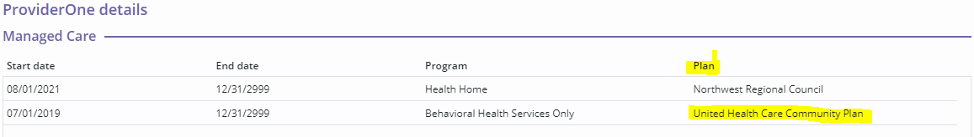

Q: I see different types of program types. What do they all mean?
Fully Integrated Managed Care (FIMC) | MEDICAID: is a Medicaid (Apple Health) managed care plan that covers physical and behavioral health benefits for clients who are Medicaid eligible.
Behavioral Health Services Only (BHSO) | MEDICAID: is a Medicaid (Apple Health) managed care plan that covers only Behavioral Health Services.
Dual- Eligible Special Needs Plan (D-SNP) | MEDICARE is a Medicare Part C managed care plan that covers physical health benefits
Health Home | MEDICAID: is a Medicaid (Apple Health) benefit that provides care coordination of medical, behavioral health and long-term services and supports for individuals of all ages.

Q: How do I know where to send my request for care coordination?
you can find a list of MEDICAID and MEDICARE MANAGED CARE COORDINATION CONTACTS here HCS - Home and Community Services
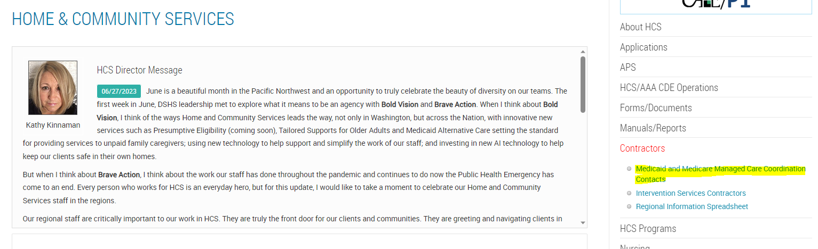
The Excel list contains multiple tabs. The first tab – “Direction Guide” provides a short description of each tab to help you contact the correct entity.

Q: How to coordinate care
- Send a secure email to the corresponding MCO using the list mentioned above.
  - In the ‘Subject’ line of the email, provide the need for care coordination request
For example: [not an exclusive list by any means]
- Care Coordination- Complex mutual client
- Durable medical Equipment
- Behavioral Health treatment
  - In the body of the email, provide the following
    - Client name
    - Client Provider One (9-digit number ending in WA)
    - Client Date of Birth (DOB)
    - Summary of client’s barriers issue/need

Q: I have more questions OR I need further support, who can I contact?
R1: Sarah Rogala sarah.rogala2@dshs.wa.gov
R2: Laura Botero laura.botero@dshs.wa.gov
R3: Genevieve Boyle genevieve.boyle@dshs.wa.gov

