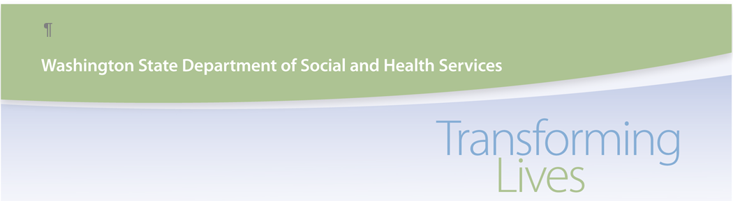
2025 Detailed Case Mix Report Run Schedule

2025 | Assessment Submission Date  *Includes submitted by close of business day | CMID Report Run During Week of:
4th Quarter Preliminary | 01/09/2025 | 01/13/2025
Revised 4th Quarter Preliminary | 02/06/2025 | 02/10/2025
1st Semi-Annual Preliminary | 04/10/2025 | 04/14/2025
Final 1st Semi-Annual | 05/08/2025 | 05/12/2025
2nd Quarter Preliminary | 07/10/2025 | 07/14/2025
Revised 2nd Quarter Preliminary | 08/07/2025 | 08/11/2025
2nd Semi-Annual Preliminary | 10/09/2025 | 10/13/2025
Final 2nd Semi-Annual | 11/13/2025 | 11/17/2025

Sets Medicaid nursing home payment rates for 07/1/2025 thru 12/31/2025
Sets Medicaid nursing home payment rates for 01/1/2026 thru 06/30/2026.

When a Case Mix Report is titled “preliminary”, corrections and/or modifications can be made and will be reflected on the next Case Mix Report that is generated. Please review and make the necessary adjustments during these Preliminary Reports as no MDS changes or modifications will be taken into consideration when the Case Mix Reports are labeled “Final 1st Semi-Annual” or “Final 2nd Semi-Annual”.
Submission of MDS Assessments and their time frames are included in each of the following Case Mix Reports:
4th quarter preliminary & Revised 4th quarter preliminary Case Mix Reports include MDS Assessments with ARD from 10/01/2024 thru 12/31/2024.
1st Semi-Annual preliminary & Final 1st Semi-Annual Case Mix Reports include MDS Assessments with ARD from 10/01/2024 thru 03/31/2025.
2nd Quarter Preliminary & Revised 2nd Quarter Preliminary Case Mix Reports include MDS Assessments with ARD from 04/01/2025 thru 06/30/2025.
2nd Semi-Annual preliminary & Final 2nd Semi-Annual Case Mix Reports include MDS Assessments with ARD from 04/01/2025 thru 09/30/2025.

