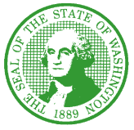

STATE OF WASHINGTON
DEPARTMENT OF SOCIAL AND HEALTH SERVICES
Aging and Long-Term Support Administration
PO Box 45600, Olympia, Washington 98504-5600
October 8, 2021

ALTSA: NH #2021-081

30-DAY EXTENSION APPROVED OF PROCLAMATION 21-15 RELATED TO THE TRANSFER AND DISCHARGE OF NURSING HOME RESIDENTS

Dear Nursing Facility/Home Administrator:

On October 1, 2021, the leadership in the Washington State Legislature extended Proclamation 21-15 that was first issued on September 3, 2021. The proclamation waives a provision in current law so that COVID-19 positive nursing home residents may be immediately transferred or discharged by a nursing home that is unable to treat COVID-19 positive patients to facilities that are equipped to treat the disease. The extension for proclamation 21-15 has been approved for a period of 30 days.

Each statutory and regulatory provision or portion thereof as specified below is hereby waived and suspended until 11:59 p.m. on November 1, 2021:
  - RCW 74.42.450(6) in its entirety, related to when a resident appeals a department decision to discharge due to level of care and waiting at least 30 days after a final order is entered
  - WAC 388-97-0140(1)(c)(ii) in its entirety, related to a skilled nursing facility/nursing facility-initiated transfer or discharge, once an appeal has been requested
  - WAC 388-97-0140(2) in its entirety, related to when a facility must suspend a transfer or discharge pending the outcome of a hearing with the office of administrative hearings

To see the details of these proclamations, use this link: https://www.governor.wa.gov/office-governor/official-actions/proclamations.

Thank you for your continued commitment to resident health and safety. If you have any questions, please contact Molly McClintock, Nursing Home Policy Program Manager, at (360) 742-6966 or molly.mcclintock@dshs.wa.gov.

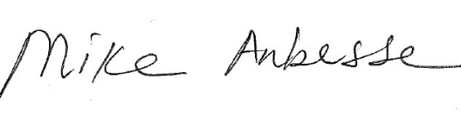
Sincerely,

Mike Anbesse, Director
Residential Care Services

DSHS: “Transforming Lives”

