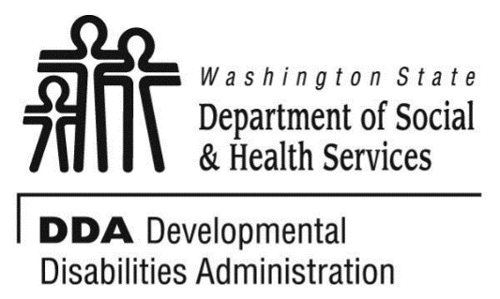

**Tacoma**

**Developmental disabilities administration**

**Continuing education Training**

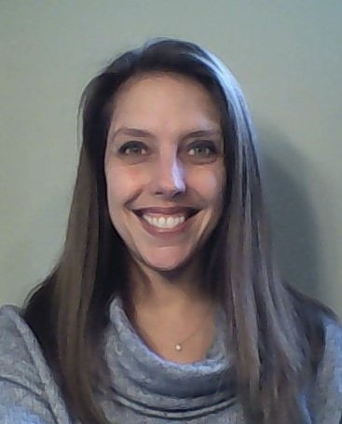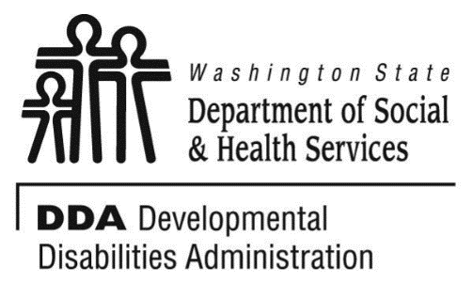

**Presenter: Laura O’Rourke**

# **Toilet Training for All Ages and Abilities 9AM-12Pm**

A 3-hour training on how to identify toilet training needs, skills, and developing a toilet training plan for individuals of any age or ability! Approved for 3 CEUs

**Learning Objectives:**

Participants will learn to identify toilet readiness skills. Participants will learn how to collect baseline toileting data and develop a toileting plan. Participants will learn research based methods for successful toileting. Participants will discuss problems and solutions to common issues that can arise.

# **Effective Nonverbal Communication-Personal Space, Body Language, and More! 1PM -4PM**

A 3-hour training on Effective Nonverbal Communication- Personal Space, Body Language, and More. Approved for 3 CEUs

**Learning Objectives:**

Participants will learn to identify effective an ineffective nonverbal cues, including useful strategies and tips for the following: Body Language, Personal Space, Posture, Eye Contact, Gestures, Tone of Voice, and Rate of Speech. Participants will practice each strategy and perform exercises which will enhance their ability to use these skills in any environment. Participants will learn how to use these strategies to prevent miscommunication and barriers to serving individuals with developmental disabilities at home, work and in the community.

**Laura O’Rourke, MS, BCBA, LMHC is the founder and Executive Director of Behavior Bridges, LLC.**

Laura has over 15 years’ experience developing & implementing behavior support services for individuals ranging in age from 1-81! She has provided services in early intervention, home based, regular & special education, supported living & employment settings. Laura provides consultation & training across WA, the United States and internationally.

**From I5 South:**

Merge onto I-705 N via EXIT 133 toward City Center

Take the A Street exit on the left toward City Center

Keep left to take the S. 15 Street ramp toward Pacific Ave

Turn slight left onto S 15th St

Turn right onto Tacoma Ave S

1305 TACOMA AVE S is on the right

**From I5 North:**

Take the I-705 N / WA-7 S exit, EXIT 133, toward City Center / Pacific Avenue

Take the exit on the left toward City Center / Tacoma Dome

Merge onto I-705 N via the exit on the left toward City Center

Take the A Street exit on the left toward City Center

Keep left to take the S. 15 Street ramp toward Pacific Ave

Turn slight left onto S 15th St

Turn right onto Tacoma Ave S

1305 TACOMA AVE S is on the right.

For Questions: Call Melody

Erickson at 253-404-5560.

Do not call to register, use form attached.

June 2nd, 2017 Total of 6 CEUs 9 AM to 4 PM

[DDA Tacoma Office, 1305 Tacoma Ave S., Suite 300, Tacoma, WA 98402](https://binged.it/2efAX8C)

**Parking is not available in the Garage attached to our Tacoma DDA office/the Work Source Bldg.**

* There are a few spots available in angle parking in front of our building’s garage on Tacoma Ave, not in front of the bldg. itself.
* There is an uncovered fenced Republic parking lot at the Tacoma Public Library (one block north of the corner of 13th and Tacoma Ave and across the street from DDA) one dollar cash per hour, $9 per day or by phone at <http://calltopark.com/> . May have to pay less for early bird specials.
* There is free street parking south of our bldg. and on perpendicular streets to Tacoma Ave, Do not park in 2 hour or other areas you are not allowed to.
* Transit, carpool, and or drop off/pick up is recommended.

You must attend all of the training to receive a certificate. Class starts promptly if you are late you will be asked to sign up for a future training.

I wish to attend these checked trainings: Toilet Training and/or Nonverbal Communication

Participants Name/s: ____________________________________________________________________

Provide Email, Fax, or Address to send confirmation notice: (Email is preferred, please put the “title” of the training and the word “registration” in email subject line when emailing registrations)

_____________________________________________________________________________________

Phone number in case of last minute changes to training: _______________________________________

**Please register early as space is limited and the training sessions fill quickly. Registration ends two weeks before date of training. We will email/send a confirmation, please allow a week to process before calling if you have not received a confirmation.**

**Please tell us at least two weeks in advance if you need a special accommodations** by writing it in the space below. We need two weeks to process your request. If you don’t receive a confirmation of this request please contact us. You can call Melody Erickson at 253-404-5560.

I need this special accommodation: ________________________________________

**Send this registration form via mail, email or fax to:**

**Melody Erickson,** Developmental Disabilities Administration

1305 Tacoma Ave. S., Suite 300, Tacoma, WA 98402

**Fax (253) 597.4368 Email–** [**melody.erickson@dshs.wa.gov**](mailto:melody.erickson@dshs.wa.gov)

**Additional classes are listed online at** <https://www.dshs.wa.gov/dda/dda-provider-training>

|  |  |  |  |
| --- | --- | --- | --- |
| Who can attend, Check one:   Licensed AFH Provider,   AFH Resident Manager,   AFH Caregiver,   Assisted Living Administrator   Assisted Living Caregiver   Companion Home Provider   Alternative Living Provider   DDA Residential Program Employee   DDA Employment Program Employee   Other, i.e. Family, parent, teachers, others who want to learn more. Please describe:  ____________________________________________ | Please fill out, if you can, the below information:  Name of Company/Employer/AFH:  ______________________________________  City of Company/Employer/AFH:  ______________________________________   Phone Number:  ______________________________________  Info about CEUs:  Individual Providers, can attend, but CEUs do not apply. IPs go through the Training Partnership for CEUs.  CE credits for others with DOH credentials may be allowable at the discretion of your licensing board. It is the responsibility of attendees with other certifications/ licenses to verify that this CE activity meets your licensing boards’ standards and acceptability as a CE event. |  |  |

June 2nd, 2017 Total of 6 CEUs 9 AM to 4 PM

**Tacoma**

**Developmental Disabilities Administration**

**toilet training and nonverbal communication**

**Registration Form**