

**Developmental Disabilities Administration**

Region 1

Presents Trainings for

Continuing Education

2017

Community Protection

Orientation and training

Presented by

Janell Featherstone

As the co-founder and co-owner of CIS, Janell has over 30 years of experience in the social service field working with children, adolescents, and families, as well as individuals with developmental disabilities. She has counseled victims of sexual and physical violence, behaviorally challenged youth, sexual offenders, and domestic violence perpetrators. Her driving passion is helping prevent victimization and abuse.

Janell is a dynamic public speaker and experienced trainer. She has made presentations to the King County Washington Public Defenders Office, in addition to social and health service agencies in Colorado, California, Washington and Arizona. She has been a speaker for national teleconferences presented by the American Network of Community Options and Resources (ANCOR) and the Irwin Siegel Agency. As a certified trainer of SmartEscape™, she provides women and children with the necessary skills to protect themselves from abduction and rape.

Janell has a Bachelor’s Degree in Psychology and a Master’s Degree in Counseling Psychology, and is a Licensed Mental Health Counselor in Washington State.

Who Should Attend?

SL Providers, Resident Managers, Caregivers, and Supported Employment Staff who support individuals in the CP program, Case Managers, and Mental Health providers. This is not for IP’s to earn their CE credits.

This training is approved for 8 hours Continuing Education.

There is no charge for this training

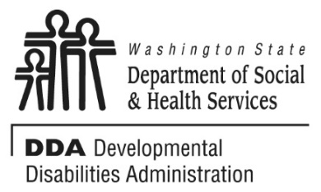

The Community Protection Orientation and Training curriculum is designed to provide an introduction to employees working with people who are developmentally disabled and have community protection issues.

At the completion of the training, trainees will be able to:

* Identify the eligibility criteria for those in the CP program.
* List common restrictions for those in the CP program.
* Identify ways the Residential Guidelines apply to people in the CP program.
* Discussion of Relationships for CP participants.
* Identify common ways offenders “groom” staff &/or victims.
* Understanding the offence Cycle.
* Define a “triangle relationships”.
* Describe common steps in the offense cycle.
* Be aware of contributing factors to sex offending.
* Be aware of staff emotional responses to working with CP participants.
* Identify staff behaviors that represent inappropriate uses of “power and control” when working with individuals in the CP program.
* Be aware of staff effectiveness skills
* Identify ways to develop mutually respectful and trusting relationship with participants.
* Explain direct service staff’s role in disclosure of confidential information regarding the CP program participant.
* Explain some of the legal issues that may apply to CP Program participants.

Location:

**Spokane Regional Health District**

[**1101 West College Avenue, Spokane, WA 99201-2095**](https://www.google.com/maps/place/1101+W+College+Ave,+Spokane,+WA+99201/@47.663151,-117.430502,17z/data=!3m1!4b1!4m5!3m4!1s0x549e185ec9deade7:0x29d34472f4c58fb2!8m2!3d47.663151!4d-117.428308)

**Room 104, Auditorium**

To Register:

* You must pre-register by contacting Trina Tenny at [**Tennytr@dshs.wa.gov**](mailto:Tennytr@dshs.wa.gov)or **509-751-4638**
* This class is limited to 30 attendees, and you must be registered to attend.

Wednesday, June 7, 2017

8 AM to 5 PM

Community Protection

**Orientation and Training**



**From I90 East:**

Take Exit 280 (Maple Street Exit)

Turn Left onto S Jefferson Drive

Turn right onto W 3rd Ave

Turn left onto S Lincoln Street

Use the left two lanes to turn left onto W Main Ave

Turn slightly right toward N Monroe St

Turn left onto W College Ave

Destination will be on your left

**From I90 West:**

Take Exit 280B to merge onto S Lincoln Street

Use the left two lanes to turn left onto W Main Ave

Turn slightly right toward N Monroe St

Turn left onto W College Ave

Destination will be on your left

If you get lost or in the event of inclement weather, call 509-751-4638 to get further direction or to find out if the training will be held as scheduled. Please don’t be late; doors will close at start time.

We ask while here that you follow safety and security rules of the venue. Please always wear the badge (when provided) and sign in/out if required by the venue. Thank you.

Directions to Spokane Regional Health District

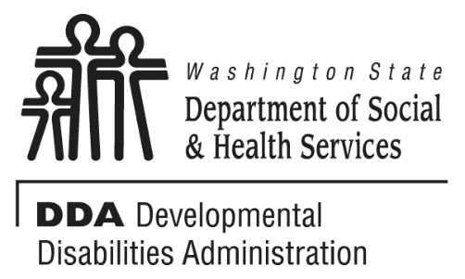

**Additional Classes are listed Online**

<http://www.dshs.wa.gov/dda/dda-provider-training>

**Purpose Statement**

**The Developmental Disabilities Administration (DDA) endeavors to make a positive difference in the lives of people eligible for services, through offering quality supports and services that are: individual/ family driven; stable and flexible; satisfying to the person and their family; and able to meet individual needs. Supports and services shall be offered in ways that ensure people have the necessary information to make decisions about their options and provide optimum opportunities for success.**

* INDIVIDUAL WORTH AND DEVELOPMENT
* CONTINUITY AND COORDINATION OF SERVICES
* COMMUNITY PARTICIPATION AND PARTNERSHIP
* RESPECT FOR EMPLOYEES
* SERVICES QUALITY AND PERFORMANCE ACCOUNTBAILITY
* NONDISCRIMINATION

Transforming Lives

**Developmental Disabilities Administration**

Region 1

Presents Workshops for

Continuing Education:

2017