

**STATE OF WASHINGTON**

**DEPARTMENT OF SOCIAL AND HEALTH SERVICES**

**PO Box 45811, Olympia WA 98504-5811**

DATE: January 29, 2025

TO: RFQQ # 2335-842 Bidders

FROM: Berle Ross, Solicitation Coordinator

DSHS Office of the Deaf and Hard of Hearing

SUBJECT: Amendment No. 03 –Bidder’s Q & A

**Question #1:**

On the application form, I notice my Certification is not showing. Can I write it in?

**A:** ODHH has included additional certifications in Amendment # 1. If your certifications are listed in Amendment #1 you can write it on Attachment D.

**Question #2:**

What is going on with the independent interpreter contract? I applied for it and was waiting to see if I was awarded the contract when I got an email saying it was cancelled. Will it open again, and will I have to re-apply all over again?

**A:** The previous solicitation was canceled due to an error in the rates. ODHH published amendment#2 with the corrected rates on January 7, 2025. The Solicitation is now open.

Yes, you have to re-apply all over again and the deadline to resubmit your offer is February 12 by 5:00 p.m. Pacific Time.

**Question #3:** If the original action was cancelled, is it still possible to submit feedback (I can't remember the exact term the contract used) about the exclusion of NIC and CDI credentialed interpreters from the contract requirements? When I looked, it still listed a date in October I believe, making it look like we can no longer submit feedback. I would love to contract directly with the state but under the current wording I do not qualify because I was certified after 2005 when the levels version of the NIC was discontinued.

**A:** ODHH has included additional certifications in Amendment # 1.

**Question #4:** Based on the information provided, it appears there is a one-hour minimum pay with additional increments of 15 minutes if the job runs over. Could you clarify if this is correct? If so, I’m curious about the reason behind this structure, as it seems inconsistent with standard interpreting practices nationwide. To my knowledge, most entities adhere to a two-hour minimum, with DSHS being an exception at 1.5 hours (which I currently only accept through SOUND).

**A:** Yes, this is a 1-hour minimum pay with 15-minute increments if the job goes over.

This is a government issues contract and the statewide contract with Enterprise Services is a Base Rate with limited travel. The Base rate was intended to cover some travel compensation. However, this new contract under DSHS includes travel so there we have eliminated the base rate.

In order states, Medicaid appointments are paid by the hour, not a 2-hour minimum. We offer a compromise with the Base Rate.

**Question #5:** Could you share your perspective on how being awarded this would be beneficial for me? At first glance, it seems like additional administrative work—such as responding to all requests within specific timeframes—without a significant increase in pay compared to going through an agency. Am I overlooking any key benefits?

**A:** A change to this contract was implemented to focus on meeting the needs of clients, and we have increased the rate structure following COLA changes.

**Question #6:**

Some of the wording on Amendment #2 - under **Updates to Bidder Qualifications RFQQ 2334-842** - was unclear to me.

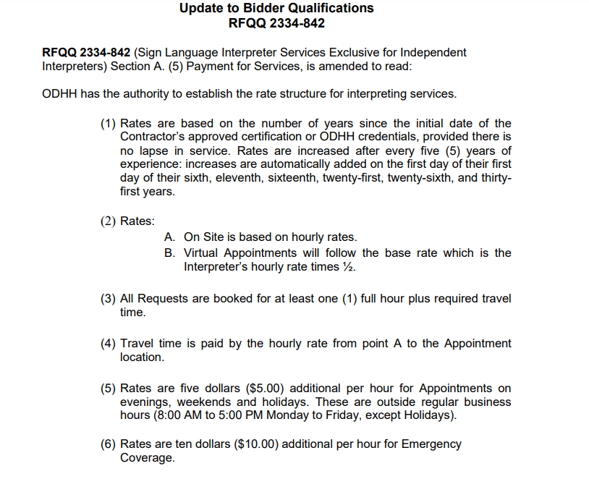

**Q.6.1.** typo...should just be one time: "on the first day of their".

**A.1.** Correct, it is a typo.

### **Section A. (5). (1)** is amended to read: Rates are based on the number of years since the initial date of the Contractor’s approved certification or ODHH credentials, provided there is no lapse in service. Rates are increased after every five (5) years of experience: increases are automatically added on the first day of their sixth, eleventh, sixteenth, twenty-first, twenty-sixth, and thirty-first years.

**Q.6.2.** On-site, in-person assignments are paid using hourly rates, not base rates, and are to include portal-to-portal travel time for all assignments.

**A.2.** Correct.

**Q.6.3.** Virtual appointments will be calculated using the base rate (ie: 1.5 x hrly rate for first hour, and hourly rate for subsequent quarters of an hour (ie: paid in 15 min increments.)

**A.3.** Correct.

**Q.6.4.** One hour minimum for all appointments (on-site/virtual). On-site to be scheduled to include anticipated required travel time. Additional approval is not required to invoice travel time.

**A.4.** Correct

**Q.6.5.** Travel time is to be paid portal-to-portal (ie: home > assignment ->home, home >assignment (not to subsequent appt.)

**A.5.** Correct

**Q.6.6.** can you pls define what is an Emergency appt? Is that scheduled for less than 4 business hours?

**A.6.** An emergency appointment Emergencies – requests for Appointments which must be scheduled with three (3) days or less notice/confirmation:

* Contractors who indicate emergency availability are required to respond to emergency requests within four (4) hours.
* Contractors are required to confirm availability/non-availability immediately through email or calls directly with the authorized Requestor
* Contractors must be prepared to provide such emergency Interpreting services as requested, including reasonable travel time.
* Prior to the emergency appointment, the Contractor must have an actual online request form, either self-entered, or entered by the Requestor.
* Contractors must provide separate communications protocol from their other business contact information for emergencies.

**Q.6.7**. Can you pls send out a list of the DSHS entities that this contract will cover? For example, I assume LNI is still outside state contracting.

**A.7**. DCYF, DSHS (HCS, DDA, RCS, APS), DVR, DSB. LNI for employees, not injured workers.

**Q.6.8.** Is anyone working to improve LNI contracting which still has no payment for client-no shows or provider cancellations < 48 hrs.

**A.8.** Refer to LNI for clarification

**Question #7:**

I am interested but noticed a couple of things that give me pause.

**Q.7.1** The first thing I noticed is that it is a 1-hour min. Is that correct?

**A.1.** Yes

**Q.7.2** I also saw that teams are only required for jobs that are 90 mins or more. Is that correct?

**A.2.** This is for independent contractors, and by national standards you can only accept a job that is 90 minutes or less without a team. Since you do not have the capability to hire and/or schedule a team under this contract, you would either have to educate the Purchaser on how to request a team or turn down the assignment.

**Q.7.3** And lastly, since this is mostly for in-person work - I did see if in person is not available then in a pinch virtual will be allowed, but that travel is limited to 2 hours max from home. Is that also, correct?

**A.3.** Virtual appointments do not include any travel. Travel for onsite appointments does not have a 2-hour max. However, jobs that require travel that exceeds 2 hours should be disclosed to the Purchaser.

**Q.7.4**. The travel time is an issue for those of us serving Eastern WA as you know there are few of us (and we just lost one to Ohio) and we cover a large area when we travel... will this 2 hour limit pose issues for us or how easy will it be to have longer distances approved?

**A.4.** There is no two-hour limit. The two-hour structure is a prompt to communicate with the Purchaser.

**Q.7.5.** In regard to the hourly min... I am hoping I read it wrong, and it will be the flat rate like we have for the other state work we do. I am not sure why interpreters would accept these direct jobs without the flat rate or the industry standard of a 2-hour min.

**A.5.** The private industry has a 2-hour min. This is a government contract. The 1 hour minimum comes with unlimited commute time to and from the appointment.

**Q.7.6.** Regarding the 90 mins as opposed to 60 min for teaming requirements - I am surprised by this as many of us find an hour to be almost too much depending on the job. Sometimes several hours is okay - it just depends, but the one hour frame gives interpreters more options. The last thing we want is to burn out the few interpreters we do have.

**A.6.** We agree, we do not want to burn out Interpreters. However, the average length of solo Virtual Assignments has been 90 minutes with a 10 min break in between. Each appointment is different. I believe that Interpreter’s will need to determine what will work best for them. Setting the cut off at 1 hour can unintendedly create an access barrier, as many appointments are less than the full 60 minutes. 90 minutes assignments have room to insert required breaks without the demand for a second Interpreter.

**Question#8:** Will HCA claims send an email when claims are rejected?

**A**. Contractors do not receive email notification if claims are denied.

Instead, the claim is listed as denied on the Remittance Advice (RA). The RAs can be downloaded from P1 in PDF format.

**Question#9:** Where can I find the DSHS rates?

**A.** The ODHH website is currently being updated to reflect the contract changes. DES and DSHS are separated contracts. The rates for Independent contractors follow the number of years of experience post Certification and have an increased percentage added to cover overhead cost. The rate structure will is below:

|  |  |  |  |  |  |  |  |  |
| --- | --- | --- | --- | --- | --- | --- | --- | --- |
|  |  |  |  |  |  |  |  |  |
|  |  |  |  |  | State Rate | State E/W/H | King County | King County E/W/H |
| 0-5 |  |  |  |  | $68.00 | $78.00 | $74.00 | $84.00 |
| 6-10 |  |  |  |  | $71.00 | $81.00 | $77.00 | $87.00 |
| 11-15 |  |  |  |  | $74.00 | $84.00 | $81.00 | $91.00 |
| 16-20 |  |  |  |  | $77.00 | $87.00 | $85.00 | $95.00 |
| 21-25 |  |  |  |  | $81.00 | $91.00 | $89.00 | $99.00 |
| 25-30 |  |  |  |  | $85.00 | $95.00 | $92.00 | $102.00 |
| 31+ |  |  |  |  | $88.00 | $98.00 | $96.00 | $106.00 |

All other terms and conditions in this Solicitation remain the same.