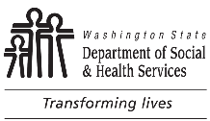 | AGING AND LONG-TERM SERVICES ADMINSITRATION (ALTSA)  HOME AND COMMUNITY SERVICES (HCS)  Nursing Services Activity Report  for HCS |  |  | REGION
 |  |  |  | REPORTING PERIOD
 |  | In-Home | Residential
 | Clients
 | Number this month
 | YTD
 | Contacts
 | Number this month
 | YTD
Send report to Lauren Palm, Administrative Assistant via email by the 15th of the following month:
PalmL@dshs.wa.gov
Phone (360) 725-2411

