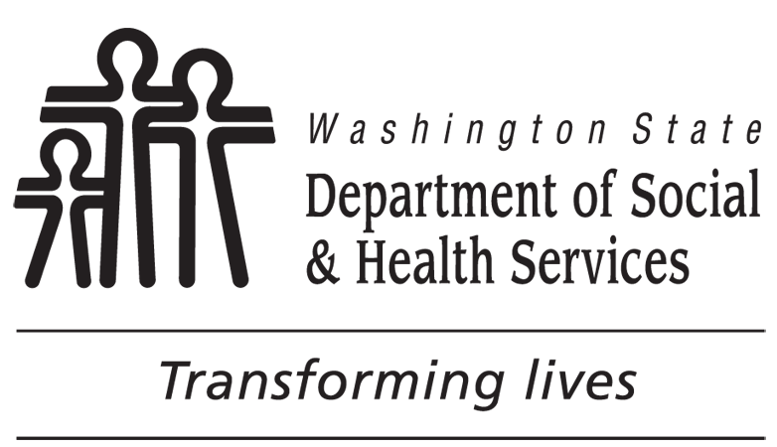 | DEVELOPMENTAL DISABILITIES ADMINISTRATION (DDA)  Community Protection Program Information Checklist  and Risk Assessment Consent
Individuals who receive Community Protection Program services agree to comply with the specialized supports and restrictions described in his or her service plan. Participation in all DDA paid services is voluntary.
The Community Protection Program:
Is a voluntary opportunity for program participants to live successfully in the community and stay out of jail, prison, or other criminal justice settings, and includes access to a wide array of services that are designed to promote independence and self-determination within the limits of personal and community safety.
Offers a specialized environment in which program participants are supported to make positive choices to reduce behaviors that require intensive intervention and supervision, in a setting that is respectful of client’s rights and is non-punitive in nature.
May include certain safeguards and restrictions which enhance the protection of others from behaviors that endanger people or property or interfere with the rights of others. Such measures could include but would not be limited to intensive supervision, door and/or window alarms, visual screening of windows and fence openings, and limited access to television programing, reading materials, videos, and the internet.
May require you to engage in therapy to address individual issues as a condition of receiving certain services. The therapist will work collaboratively with the residential and employment providers to recommend appropriate supervision, supports and restrictions designed to reduce the likelihood of a person engaging in targeted behaviors both at home and in the community. Only the least restrictive interventions that effectively meet the goal of public safety may be used, and reductions to restrictive measures will be considered when appropriate.
Involves collaboration and coordination (including the sharing of information about client’s Community Protection issues) between DDA staff, residential providers, employment providers, therapists, and other agencies or individuals, such as law enforcement, corrections officers, schools, and mental health workers.

Participants in the Community Protection Program are restricted from accessing other services available through DDA such as non-CP residential supports, respite, and other services available through other DDA waivers.
You will be required to sign a Preplacement Agreement as a condition of receiving community protection program residential services.
You have the right to decline services, though by doing so you may lose existing services and be removed from DDA waiver services. If you are offered and refuse Community Protection residential services, you may only receive case management and Community First Choice (personal care) through DDA. Services offered through other administrations (such as Home and Community Services, or Vocational Rehabilitation) may still be available to you.
If you disagree with a decision made by DDA, you may have the right to an administrative hearing as specified in WAC 388-825-120 through 388-825-165, including an emergency adjudicative proceeding as specified in RCW 34.05.479. You also have the right to retain current services during appeal as specified in WAC 388-825-145 or 388-825-150.
Further information about your rights is available through Disability Rights of Washington (DRW), and may be requested by calling 1-800-562-2702.
CLIENT’S SIGNATURE DATE |  | OTHER SIGNATURE DATE
LEGAL REPRESENTATIVE’S SIGNATURE DATE |  | CASE RESOURCE MANAGER’S SIGNATURE DATE
I grant permission for the administration of a risk assessment by a qualified provider of my choice that is contracted with the Developmental Disability Administration, and I understand that the risk assessment will be forwarded to the regional Community Protection Committee for review and determination regarding my eligibility for the Community Protection Program.
OR
I DO NOT grant permission for the administration of a risk assessment and I understand that my refusal to participate in a professional assessment may affect my eligibility for other services that are available through DDA such as residential, respite, and vocational supports. Services offered through other agencies (such as Home and Community Services, or Vocational Rehabilitation) may still be available.

