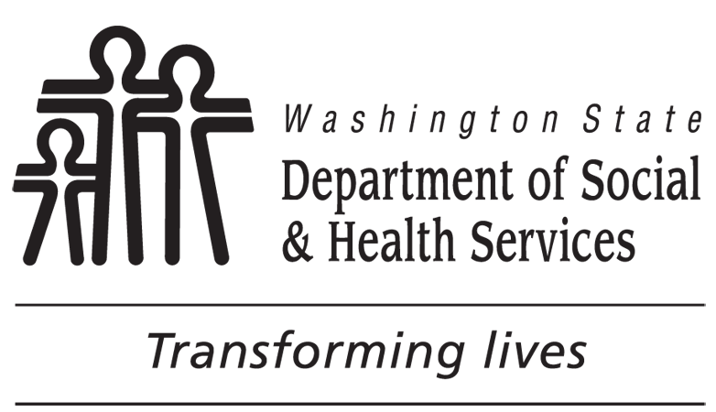 | Extended Foster Care Program Consent
You have chosen to be part of the Extended Foster Care Program. While in the Extended Foster Care Program, your health care providers and other people involved in your care need to be able to talk to each other about your health and/or behavioral / mental health care. They also need to share your health and/or behavioral / mental health information with each other to give you better care. If you do not sign this form or do not want to be in the Extended Foster Care Program, you will still be able to get health care benefits as long as you are eligible for Apple Health (Medicaid) coverage.
If you agree and sign this form, the Fostering Well-Being Program (FWB) and the partners listed on this form are allowed to get, see, read, copy, and share with each other ALL of your health information that they need to help you manage your care. The health information they get, see, read, copy, and share may be from before and after the date you sign this form. Your health records may have information about illnesses or injuries you have or may have had before; test results, such as x-rays, or blood tests; and the medicines you are taking now or have taken before. Your health record may also have information on:
- Substance Abuse programs, which you are in now or were in before;
- Family planning services like birth control and abortion;
- Inherited diseases;
- HIV/AIDS;
- Behavioral / Mental health conditions; and/or
- Sexually-transmitted diseases (STD) / Sexually-transmitted infections (STI) (diseases or infections you can get from having sex).
Your health information is private and cannot be given to other people without your permission under Washington State and U.S. laws and rules. The partners who have your health information cannot give your health information to other people unless you agree or the law says they can give the information to other people. This is true if your health information is on a computer system or on paper.
I AGREE to allow the FWB to get ALL of my health information from the partners listed on this form to assist me in managing my care, and to check if I am in a managed care plan and what benefits I am eligible for. I also AGREE that the partners listed on this form may share my health information with each other. I can change my mind and take back my consent at any time by signing a Withdrawal of Consent Form and giving it to my Social Worker or to the FWB program. This will not affect any information already shared.
I specifically give permission for the following information to be disclosed:
INFORMATION TO BE DISCLOSED INITIALS
HIV / AIDS and STD / STI test results, diagnosis or treatment records (RCW 70.24.105)
Behavioral / Mental Health records (RCW 71.05.620)
Substance Use Disorder patient records (42 CFR Part 2)
Some laws cover care for HIV / AIDS, behavioral / mental health records and substance abuse. The partners that use your health information must obey these laws. Please read all the information on this form before you sign it.
Unless previously revoked by me, the specific information above is valid until .
EXPIRATION DATE
PRINT NAME OF CLIENT |  | CLIENT’S DATE OF BIRTH
CLIENT’S OR CLIENT’S LEGAL REPRESENTATIVE’S SIGNATURE |  | DATE
PRINT NAME OF LEGAL REPRESENTATIVE |  | RELATIONSHIP OF LEGAL REPRESENTATIVE TO CLIENT
LIST THE NAME OF PARTICIPATING PARTNERS |  | DATE | CLIENT INITIALS

