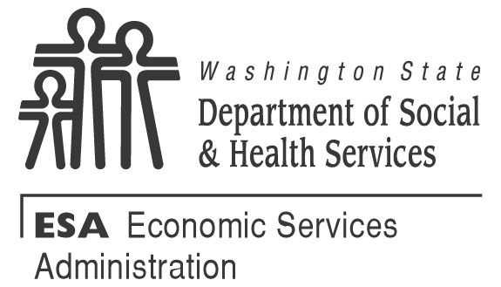
Appointment Letter for Division of Child Support (DCS)
Good Cause Determination
Date: Client Number:
To:
Dear ,
You have requested Good Cause and told your local Community Services Office that you are not able to help the Division of Child Support (DCS) collect child and/or medical support. DCS provides full support enforcement services when you receive TANF. These services may include DCS establishing paternity, entering and/or enforcing a support order, enforcing the other parent’s obligation to provide health insurance and contributing his/her share of uninsured medical expenses for your children. I have set aside the following appointment to talk with you about your Good Cause request to stop any child and medical support actions.
I have set aside the following appointment to talk with you about your Good Cause request to stop any child and medical support actions.

ADDRESS DATE TIME
If you cannot come, please call me at by . If you do not call or come to your appointment, I may deny your Good Cause request.
I will approve this Good Cause request if it is determined:
- You fear you or the child(ren) in your care will be seriously harmed physically or emotionally.
- Your child was born due to rape or incest.
- You have started adoption proceedings, or you are in counseling (for up to three months) with a child placement agency about adoption.
At the appointment, you can write a signed statement that describes your concerns and fears. You can also bring other information with you to support your request, if available. Some examples are:
- Police report(s);
- Medical report(s);
- Court report(s);
- Domestic violence protection order;
- Written statement from clergy, friends, relatives, neighbors, co-workers describing the danger;
- Letter from domestic violence shelter(s); or
- Letter from domestic violence counselor(s).
What happens at this appointment?
- You will be able to explain why you fear collecting child and medical support could harm you or your child(ren).
- We can talk about other help you may need in order to stay safe.
What happens if you don’t provide a signed statement or other information to show why collecting child and medical support could harm you or your child(ren)?
- Your request may be denied if we do not find that the reason(s) given meet the requirements for granting Good Cause and
- Your case will be sent to the DCS to open a child support case for full support enforcement services.
- There may be a domestic violence advocate at your local CSO or in your community who could be available to attend this meeting with you. Contact your local CSO for more information.
What if you don’t agree with our decision?
- You can call your Community Service Office or write to the Office of Administrative Hearings, PO Box 42489, Olympia WA 98504-2489 within 90 days to request a hearing. If you request a hearing, DCS will not start working your case until the hearing decision is final. A lawyer or other person can represent you at the hearing, or you can represent yourself.
- Withdraw your request for TANF. However, DCS may work your case for the time your received TANF.
- Continue to receive assistance and not participate in support enforcement activities. However, if you do not participate in support enforcement activities DCS will continue to work your case and your cash assistance may be reduced by 25% if your Good Cause request is denied.
A lawyer or other person you choose can represent you at the hearing, or you can represent yourself.
Can you get legal advice or presentation?
You can call the statewide legal services line at 1-888-201-1014.

