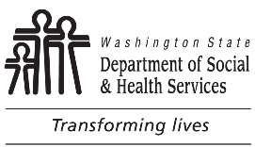 |  | STATE OF WASHINGTON  DEPARTMENT OF SOCIAL AND HEALTH SERVICES  DIVISION OF CHILD SUPPORT (DCS)  Declaration of Support Payments

List the child support you received directly from the noncustodial parent from to
for the children listed below.

Do not include payments you received from the Division of Child Support. Page 2 has space for five additional years if needed. Attach additional pages if necessary.
NOTICE: You must complete the Declaration section on page 2.
NONCUSTODIAL PARENT'S FULL NAME |  |  | CUSTODIAL PARENT'S NAME |  | CASE NUMBER

Year

January

February

March

April

May

June

July

August

September

October

November

December

Total

Year

January

February

March

April

May

June

July

August

September

October

November

December

Total

Declaration

I declare under penalty of perjury, under the laws of the state of Washington, that the foregoing is true and correct.

Signed at , Washington.
DATE |  | YOUR SIGNATURE
Return to:
DIVISION OF CHILD SUPPORT
PO BOX 11520
TACOMA WA 98411-5520

