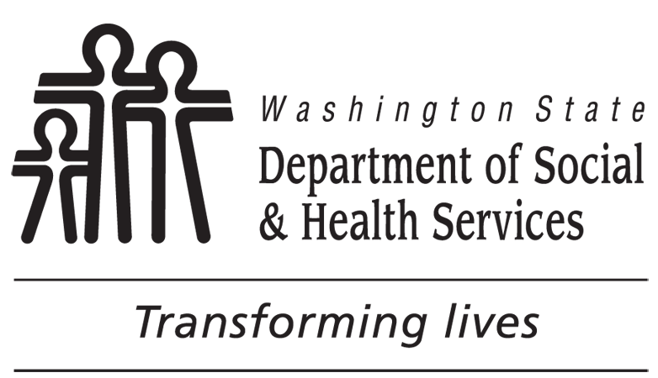 |  | Loan Agreement for Tools, Equipment,  Initial Stock and Supplies, and Devices
CUSTOMER’S NAME |  |  | SOCIAL SECURITY NUMBER |  | VRC NAME (PRINT)
EMPLOYMENT GOAL |  |  | TYPE OF SERVICE(S) (FOR VR STAFF USE ONLY)  Tools, equipment, initial stock and supplies Transportation  AT devices Training Self –employment  Other:
AUTHORIZATION (APF) NUMBER | VENDOR NAME |  | INVOICE NUMBER | DESCRIPTION (INCLUDE SERIAL NUMBER IF APPLICABLE) |  | $ AMOUNT

Total |  |  |  |  | $
LOAN AGREEMENT (SEE REVERSE FOR LARGER PRINT)
I (DVR customer) understand that DVR has ownership of the item(s) listed on this form and loaned to me for use. If DVR is loaning me the item(s) to start a business in partnership with other individuals, I understand the item(s) is loaned to me as a part of my Individualized Plan for Employment and does not belong to the business or any partner with interest in the business. I have a written agreement with my business partner(s) that documents they share this understanding and am attaching it to this Loan Agreement. Further, by signing this form I agree to the following: (1) I agree to immediately return the item upon request; (2) I agree to maintain the item according to DVR instructions and manufacture’s guidelines, if applicable, and keep it secure from damage, loss or theft. WAC 388-891A-1200.
In accordance with WAC 388-891A-1230, I understand that if DVR directs me to return any item loaned to me and I do not immediately return it, DVR will report the loss to the DSHS Office of Financial Recovery (OFR). OFR will attempt to recover the loaned item or seek payment for the loaned item from me in an amount equal to the original purchase price. If OFR cannot recover the item or obtain payment from me for the loaned item, the OFR may report the loss to the local county prosecutor for criminal prosecution.
Further, for a loaned vehicle, I agree to be the registered owner and that DVR is the legal owner on the vehicle title. Upon request of DVR, I agree to return the vehicle to DVR and sign the vehicle title removing me as the registered owner.
In accordance with WAC 388-891A-1240, I understand that DVR may transfer ownership of the equipment or other item to me at the time my case service record is closed if I have achieved an employment outcome and I need the item to keep my job or continue operating a business that DVR has assisted me in starting.
Signature of Agreement
I understand the agreement above and am willing to comply with the terms.
CUSTOMER/GUARDIAN SIGNATURE DATE |  | VRC’S SIGNATURE DATE
Transfer of Ownership
Title to the above listed item(s) is hereby transferred to the customer whose name appears above. |  |  | VRC’S SIGNATURE DATE
 |  |  | CUSTOMER/GUARDIAN SIGNATURE DATE
Recovery
RECOVERY  Yes No | VRC’S SIGNATURE | CUSTOMER/GUARDIAN SIGNATURE |  | DATE
CONDITION OF TOOLS, EQUIPMENT, DEVICES, ETC.

Loan Agreement
I (DVR customer) understand that DVR has ownership of the item(s) listed on this form and loaned to me for use. If DVR is loaning me the item(s) to start a business in partnership with other individuals, I understand the item(s) is loaned to me as a part of my Individualized Plan for Employment and does not belong to the business or any partner with interest in the business. I have a written agreement with my business partner(s) that documents they share this understanding and am attaching it to this Loan Agreement. Further, by signing this form I agree to the following: (1) I agree to immediately return the item upon request; (2) I agree to maintain the item according to DVR instructions and manufacture’s guidelines, if applicable, and keep it secure from damage, loss or theft. WAC 388-891A-1200.
In accordance with WAC 388-891A-1230, I understand that if DVR directs me to return any item loaned to me and I do not immediately return it, DVR will report the loss to the DSHS Office of Financial Recovery (OFR). OFR will attempt to recover the loaned item or seek payment for the loaned item from me in an amount equal to the original purchase price. If OFR cannot recover the item or obtain payment from me for the loaned item, the OFR may report the loss to the local county prosecutor for criminal prosecution.
Further, for a loaned vehicle, I agree to be the registered owner and that DVR is the legal owner on the vehicle title. Upon request of DVR, I agree to return the vehicle to DVR and sign the vehicle title removing me as the registered owner.
In accordance with WAC 388-891A-1240, I understand that DVR may transfer ownership of the equipment or other item to me at the time my case service record is closed if I have achieved an employment outcome and I need the item to keep my job or continue operating a business that DVR has assisted me in starting.

Agreement of Business or Partner(s) about
Ownership of Equipment Purchased
for a DVR Customer
To be used when a Self-employment plan includes business partners.
The Division of Vocational Rehabilitation (DVR) has ownership of the following item(s):

The above items are identified on the DVR Loan Agreement form.
DVR has loaned the item(s) to for the purposes of starting a business in partnership with other individuals.
The items are owned by DVR and are on loan as part of an Individualized Plan for Employment; they do not belong to the business or any partner with an interest in the business.
By signing, , and his/her business partners identified below, acknowledge and agree that the item(s) listed above and on the DVR Loan Agreement do not belong to the business or partner(s) unless or until DVR has transferred ownership of the items.
CUSTOMER / GUARDIAN’S SIGNATURE DATE |  | PRINT NAME
BUSINESS REPRESENTATIVE / PARTNER’S SIGNATURE DATE |  | PRINT NAME
BUSINESS REPRESENTATIVE / PARTNER’S SIGNATURE DATE |  | PRINT NAME

