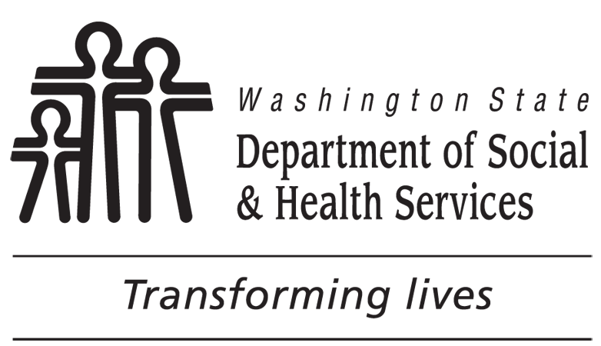 | STATE OF WASHINGTON  DEPARTMENT OF SOCIAL AND HEALTH SERVICES  BACKGROUND CHECK CENTRAL UNIT (BCCU)  (360) 902-0299  Applicant Request for a Copy of Background Check Information
Complete Section A AND Section B to request a copy of your Background Check Information.
NOTE: Applicants will automatically receive a mailed copy of their background check results if records found. Please allow five (5) business days from date of final background check result letter.

Section A
REQUIRED: APPLICANT’S FULL NAME (FIRST, MIDDLE, LAST)

REQUIRED: DATE OF BIRTH (MM/DD/YYYY) |  | APPLICANT’S PHONE NUMBER (INCLUDE AREA CODE)
REQUIRED: APPLICANT’S MAILING ADDRESS APT. NO. CITY STATE ZIP CODE

APPLICANT’S EMAIL ADDRESS

REQUIRED - I have attached a copy of my valid government issued picture identification (ID):
US Driver’s License (including WA State Learner’s Permit) US Armed Services ID
Federally Recognized Tribal ID US Passport Foreign Passport with photo and signature
Other

Section B
I AM REQUESTING A COPY OF MY: (At least one box must be checked.)
A specific background check for the following:
- BCCU Inquiry ID/OCA Number:
- Last background check requested by Entity Name:
Final Fingerprint based background check result.
Additional Information Needed Packet for Inquiry ID/OCA Number:
I would like MY above background check information sent by: (Check only one box. If neither or both boxes checked, BCCU will mail background check information.)
EMAIL to the email address listed above; OR
MAIL to the address listed above.
If email selected, BCCU will send a validation email prior to sending background check information to confirmed email address. If no email response received after two (2) business days from the applicant, BCCU will mail background check information to the above mailing address.
I understand the BCCU will provide me with all background information contained in its files that can be released under the law. I also understand the information provided to me may include one or more of the following documents: BCCU result notification, Background Check Authorization form; thumbprint results; Federal Bureau of Investigation results; other courts or agency documents received by BCCU; applicant affidavits; or Washington State Patrol results. I certify under penalty of perjury that all foregoing information is true and correct and I am the person named above.
REQUIRED: SIGNATURE (MUST BE SIGNED BY APPLICANT OR PARENT/GUARDIAN IF UNDER 18 YEARS OLD.) |  |  | REQUIRED: DATE SIGNED (MM/DD/YYYY)

Send your completed and signed Applicant Request for a Copy of Background Check Information to BCCU:

FAX: (360) 902-7954

MAIL: PO Box 45025, Olympia, WA 98504-5025

EMAIL: bccuinquiry@dshs.wa.gov
BCCU will review the request and contact the applicant if they have any questions. It is the applicant’s decision if they want to share background check information with any current or prospective employer. Background Check Results CANNOT be mailed or emailed to the applicant’s place of employment using this form.

