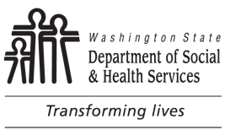
Notice and Consent of Communication
via Text or Unencrypted Email
Notice: Text messaging and unencrypted emails are not a secure form of communication. There is a risk that any individually identifiable health information and other sensitive or confidential information contained in these communication methods may be misdirected or intercepted by unauthorized third parties. If you wish to use this form of communication, you may consent to receive text messages or unencrypted emails from the Department of Social and Health Services (DSHS) regarding your services.
- This consent does not require the Department to communicate with you exclusively using text messaging.
- DSHS cannot refuse you benefits if you do not sign this form.
Consent: Please read the following and sign below to acknowledge your consent to communication via text or unencrypted emails.
I understand and accept the risk of sending and receiving information from DSHS via text messaging and unencrypted emails. I consent to use of:
Text Messaging
Unencrypted Email
I understand that I can withdraw my consent in writing at any time.
Signature Date | Print your name here. | Date of Birth
Authorized mobile number (include area code) | Client Identification Number
To Terminate Authorization
I, , choose to withdraw my permission to
(print name)
receive text messages or unencrypted e-mails; this will not affect information previously disclosed.

Client signature Date

