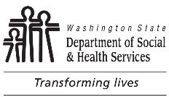 | Central Contracts and Legal Services (CCLS)  Small Business Self-Certification Statement
Chapter 39.26.010 RCW, Definitions states:
(21) “Small business” means an in-state business, including a sole proprietorship, corporation, partnership, or other legal entity, that:
(a) Certifies, under penalty of perjury, that it is owned and operated independently from all businesses and has either:
(i) Fifty or fewer employees; or
(ii) A gross revenue of less than seven million dollars annually as reported on its federal income tax return or its return filed with the Department of Revenue over the previous three consecutive years; or
(b) Is certified with the Office of Women and Minority Business Enterprises under Chapter 39.19 RCW.

I hereby certify, under penalty of perjury, that Legal Name of Entity meets the above definition of “small business.”
Signature of person authorized to sign on behalf of legal entity Date

Written name of person authorized to sign on behalf of legal entity

